EXP 7
Write a Servlet program to store a user's preferences (like theme or language) using cookies. Retrieve and display these preferences on subsequent visits. Write a Servlet program to store a user's preferences (like theme or language) using cookies. Retrieve and display these preferences on subsequent visits.

AIM
To create a Servlet-based web application that stores user preferences (such as theme or language) using cookies and retrieves them on subsequent visits.
ALGORITHM
- Start the application.
- Accept user preferences (theme/language) through a form.
- Create cookies for each preference.
- Set the cookie expiry time.
- Store cookies in the client’s browser.
- When the user revisits the application:
  - Read cookies from the request.
  - Check for stored preferences.
- If cookies are found:
  - Retrieve and display the stored preferences.
- If cookies are not found:
  - Display default values or ask the user to set preferences.
- Stop the application.
STEPS
- Design a user interface to collect preferences like theme and language.
- Configure a Servlet to handle form submission.
- Use cookies to store the user’s preferences in the browser.
- Set an appropriate expiry time for cookies.
- Send cookies along with the response to the client.
- On subsequent visits, retrieve cookies from the request object.
- Extract stored values (theme/language).
- Display the preferences to the user dynamically.
- Handle cases where cookies are absent by showing default settings.
OUTPUT:
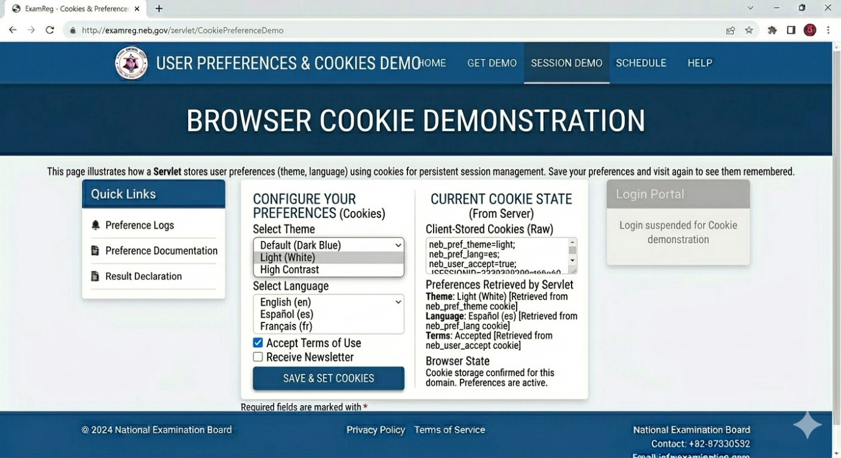

RESULT
The Servlet application successfully stores user preferences using cookies and retrieves them on subsequent visits, providing a personalized user experience.

